# Assignment 1

## Due Date:

Softcopy: 9th February, 2020, Sunday, at 11:59PM.

Hardcopy and Demo: The first day your class takes place after the softcopy is due. Check the course Calendar in eConestoga under Content->Course Information->Schedule Summary.

## Topic:

Build a mobile web app prototype with jQuery and jQuery Mobile. This prototype will be utilized in the subsequent assignments. Assignment 2 and 3 will be built on top of Assignment1. You must complete assignment 1 before proceeding any other future assignments.

## Before you begin:

* You must know how to search and use the online jQuery Mobile Docs to enhance your mobile app.
* Make yourself familiarize with the hands on examples done in the lab during class time.
* Make sure you see the screenshots in color, as you will be required to match the color themes used.
* The assignment specification and screenshots are made assuming a student’s name Jason Bourne (and initial is JB). Replace Jason Bourne with your full name, JB with your own initial. Also replace xx with your own initials.
* Make sure to fulfill all programming and assignment standards. The Standards Summary is available at eConestoga.
* All id attributes must have your initial (e.g., jb for Jason Bourne) as prefix.

## Problem Specification:

### Task 1: Application icon

* Create your own app icon (xx-icon.png, where xx is your initials).
* Please do not choose the same icon used in the screenshot below.
* Check <http://www.iconarchive.com> to get your free icon.

### Task 2: Create your mobile app project

* Project/ Folder name: xxFeedbackA1, where xx is your initials
* Add the required library files. The required library files for jQuery and jQuery mobile are available at

eConestoga->Table of Content->Resources->_lib.

### Task 3: Build your prototype

* Create an html file, if viewed on a browser will match the screen shots provided.
* Name the file as index.html. NO need to add prefix in the name of this file.
* The html file will contain 5 pages.
* For each page add 3 sections: header, content, and footer
* Header and footer section is fixed; they will always be in sight when scrolling a lengthy page.
* For each header section, the title must match the current action (e.g., List of Reviews is displayed when the Reviews tab is selected)
* For navigation bar tab selection must persist and change the color showing the tab is currently selected.
* Match the color themes as screenshot. Unselected: White, Selected: Blue
* Special(Phone/Email/External Link): White
* Prefix the id attribute of page, listview and input elements with your initials (e.g., xxHomePage)

### Task 4: Home Page

* Set the template data to match the design layout including the title and header (XX Feedback A1) similar to the screenshots below.
* Use your xx-icon.png to display the image. Use your own Student Name instead of Jason Bourne and your own initial instead of JB and xx.
* The 3 buttons at the bottom are links. Use anchor tag and make them look like buttons.

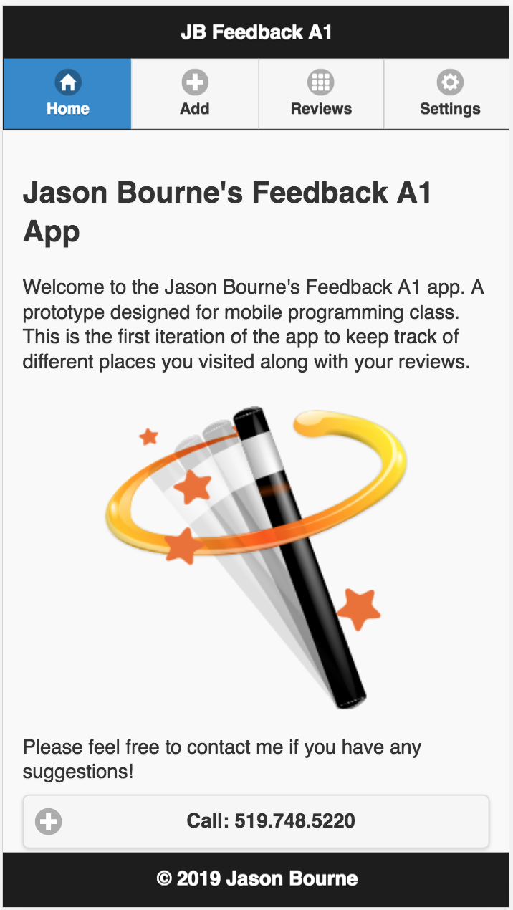

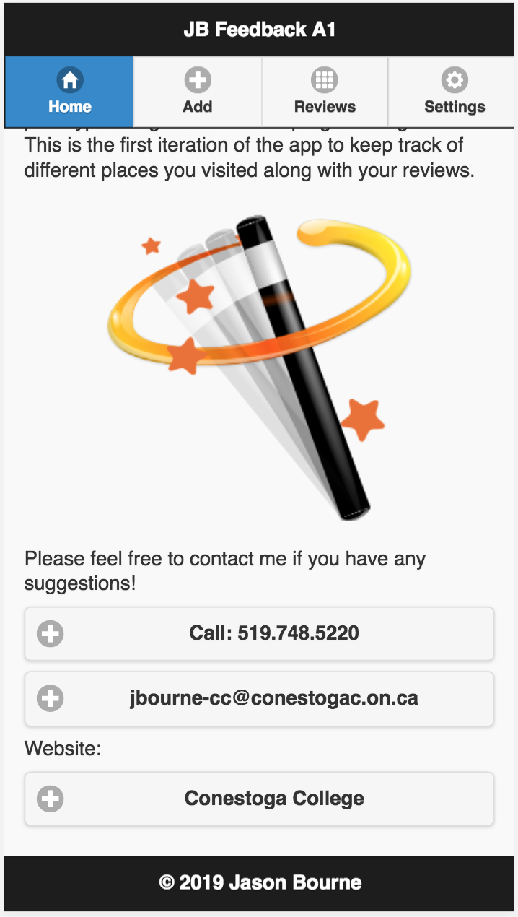

### Task 5: Add Feedback Page

* Set the page’s Id to xxAddFeedbackPage, where xx is your initials.
* Add the template data to match the design layout including the header (Add a Feedback) similar to the screenshot shown below.
* Assign a form id that it unique (i.e., xxAddForm)
* Business name and email are text input fields
* Comments is a textarea input field.
* Rating is a numeric input field
* Save button is a “Button” not an <a>
* All input controls (textbox, buttons, textarea etc.) must have proper id and name with your initial as prefix.
* No form validation is needed, save button does not do anything in this assignment.

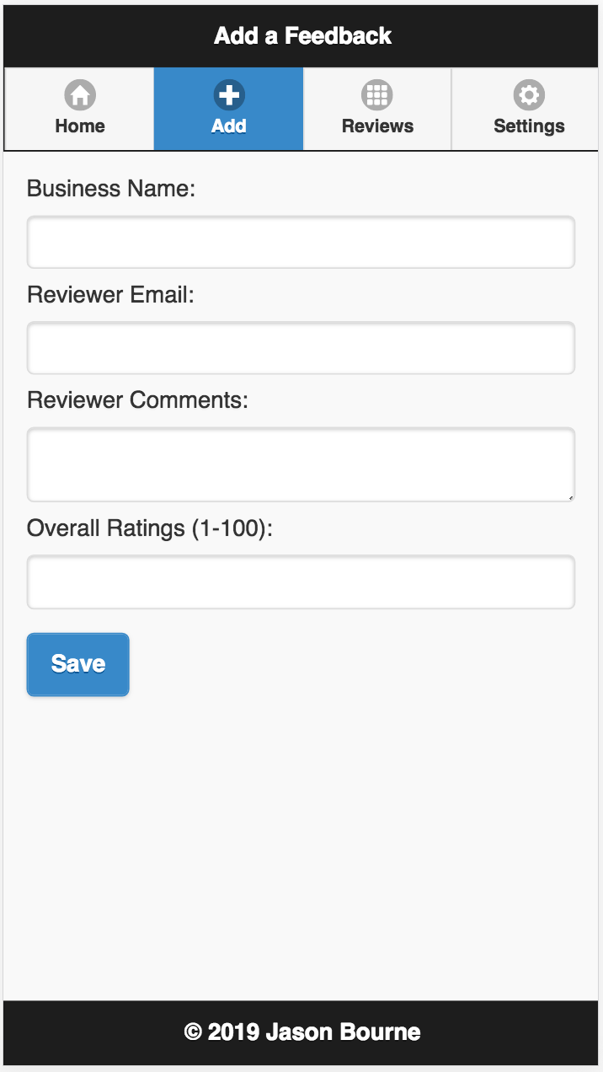

### Task 6: List of Reviews Page

* Set the page’s id to xxViewFeedbackPage, where xx is your initials.
* Add the template data to match the design layout including the header (List of Reviews) similar to the screenshot shown below.
* Provide your own sample realistic data. Do not use My Coffee Shop and My Burger Shop as your template data.
* Assign listview id that it unique (i.e., xxFeedbackList)
* Both items have a link to the same xxEditFeedbackPage (next task).
* This is just a prototype. The two items have static data. In future assignment you will require to provide dynamic data.

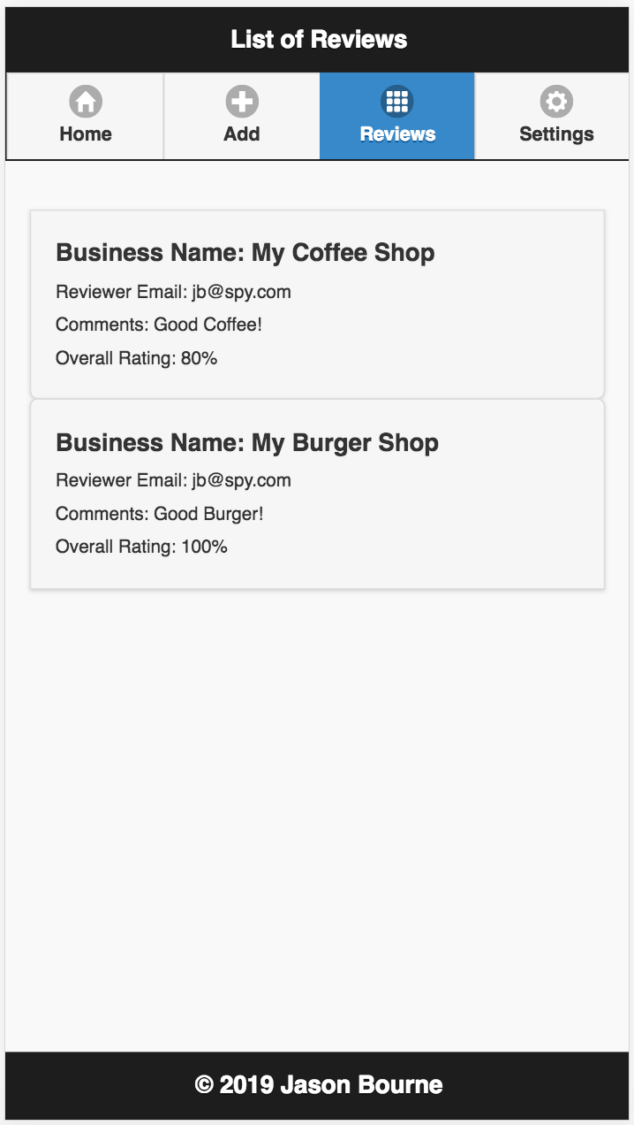

### Task 7: Modify Feedback Page

* Set the page’s id to xxEditFeedbackPage.
* Add the template data to match the design layout including the header (Modify Feedback) similar to the screenshot shown below.
* Match the default data to the first item of Task 6 (your own sample data).
* This page is similar to the xxAddFeedbackPage except for the header and buttons (Cancel, Delete, Update) and some static values in the input fields.
* Give ids and names for all input controls (textbox, buttons etc.) with your initial as prefix.
* Cancel, Delete, Upate are “Buttons”, not <a>
* This is a prototype. The buttons do not need to work.

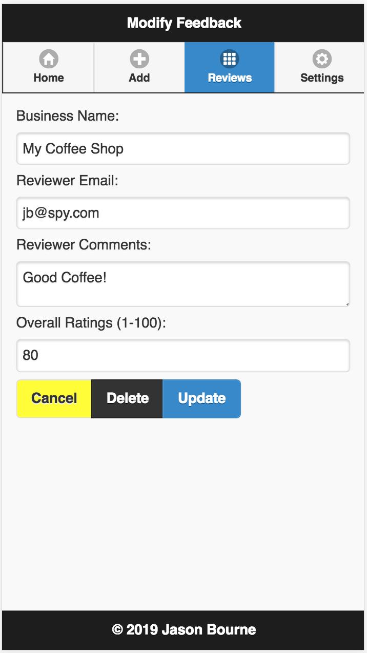

### Task 8: Settings Page

* Set the page’s id to xxSettingsPage.
* Add the template data to match the design layout including the header (Settings) similar to the screenshot below.
* All input controls will have your initial as prefix for id and names.
* The buttons (not <a>) in this page do not need to work.

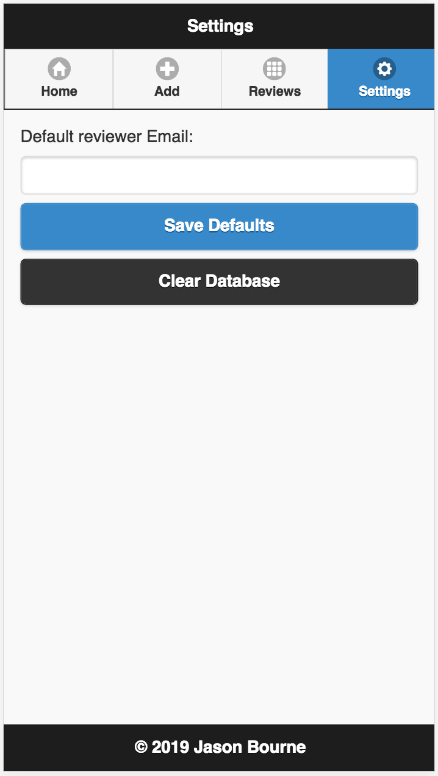

### Task 9: Test your app

* Go to Developer Tool of chrome. Click toggle device toolbar icon located on the upper left side of the Developer Tool window. Choose Pixel 2 as your device screen.
* Take screenshot of all the 5 pages.
* Save your screenshots to xxA1Screenshots.doc file.

### Task 10: Upload app

* Make a zip file xxAssignment1.zip that will contain
  + Complete project for your app
  + xxA1Screenshot.doc file.
  + After unzipping, I should be able to run your application without any modification.
* Login to eConestoga and upload to the dropbox: Assignment 1.
* For late submission: marks will be deducted per day as specified on the cover page.

### Task 11: Demo your app

* Demo your app during class time. Check course calendar available at eConestoga under Course Information->Calendar for the demo dates.
* Bring your hard copy during the demo containing:
  + Assignment coversheet and marking sheet
  + Printout of HTML File
  + Printout of xxA1Screenshot.doc containing all screenshots
  + Assignment 1 marking sheet (The last page of this document)
* If you choose not to demo at all, you may drop the hardcopy of your assignment at 2A603; in this case marks will be deducted, see the marking sheet for details. However, if you don’t submit the hardcopy, marks will not be uploaded.

# Marking Sheet

|  |  |  |  |
| --- | --- | --- | --- |
|  | Description | Marks Allocated | Marks Achieved |
| 1 | Home Page designed as specified | 15 |  |
| 2 | Add a Feedback page is designed as specified | 20 |  |
| 3 | List of Reviews page is designed as specified | 15 |  |
| 4 | Modify Feedback page is designed as specified | 15 |  |
| 5 | Settings page is designed as specified | 10 |  |
| 6 | Every page has 3 main sections. | 10 |  |
| 7 | Header and footer are fixed. | 5 |  |
| 8 | 5 Screenshots | 10 |  |
| Deduction | | | |
|  | Assignment Standard | 5 x ________ |  |
|  | id attribute is missing for any input control | 3 x ________ |  |
|  | name attribute is missing for any input control | 3 x ________ |  |
|  | Id, name not prefixed with initial | 2 x ________ |  |
|  | Programming Standard | 1 x ________ |  |
|  | Bug | 3-10 based on severity |  |
|  | Late | ­­_________days |  |
|  | No Demo | 40 |  |
|  | No hardcopy | 100 |  |
| Total | |  |  |